Scenario is to connect the master and slave server ,

1)create the two server name called master another one server name is slave server

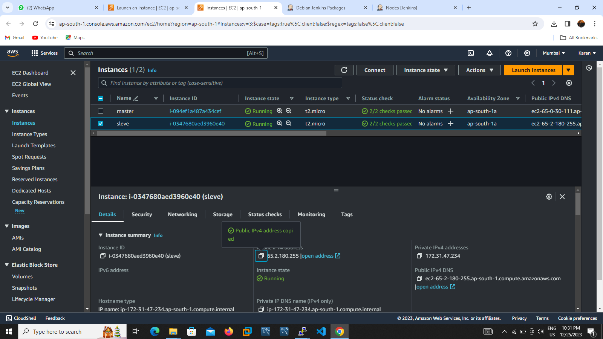

2)Next step login to putty on mater server install java and Jenkins and paste the browser public ip with port ,once ensure java and Jenkins installed or nor by using below command java –version and Jenkins --version

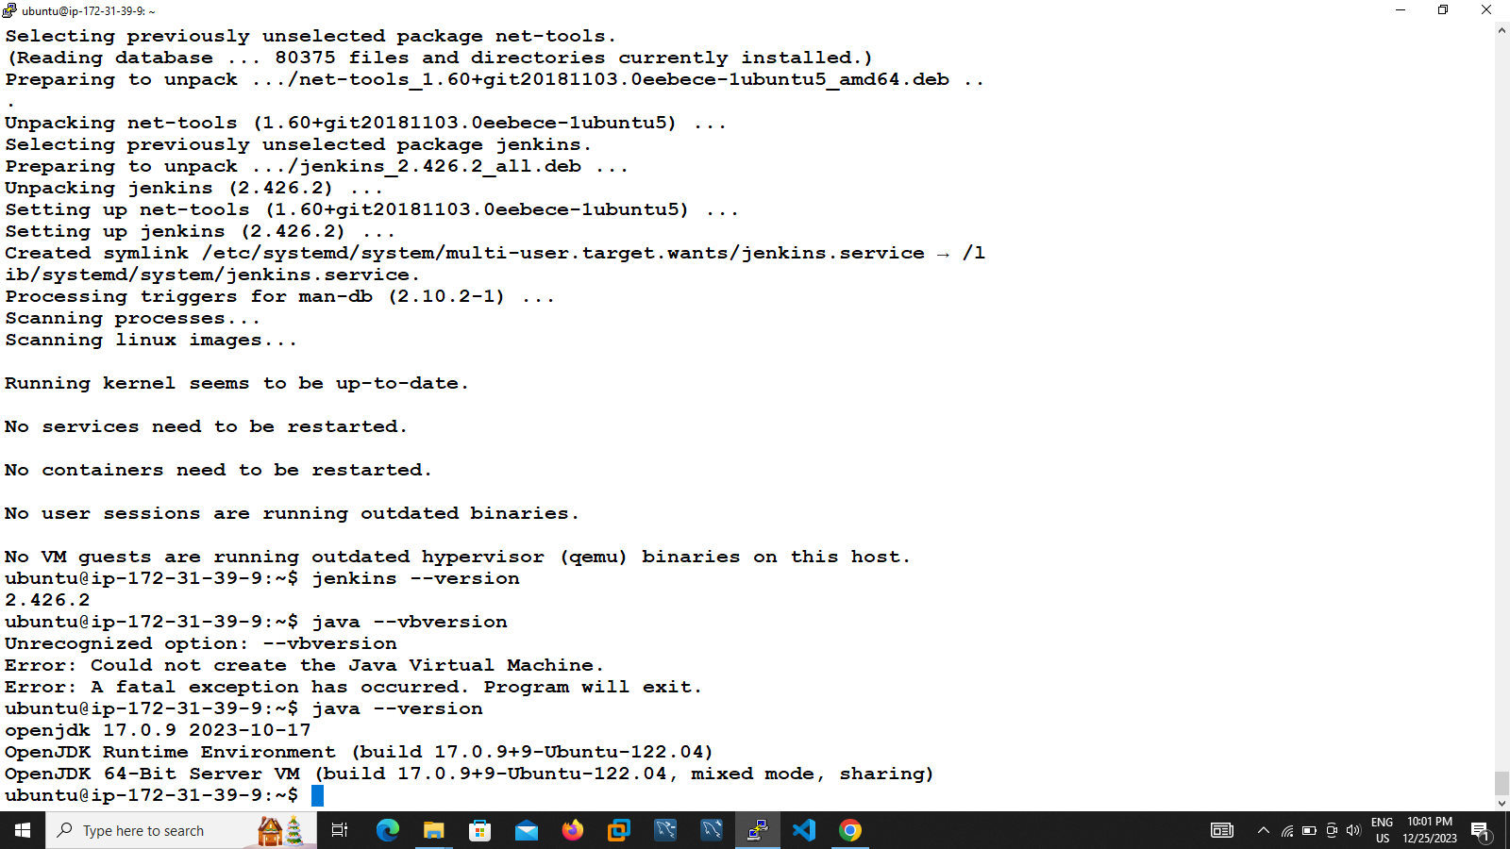

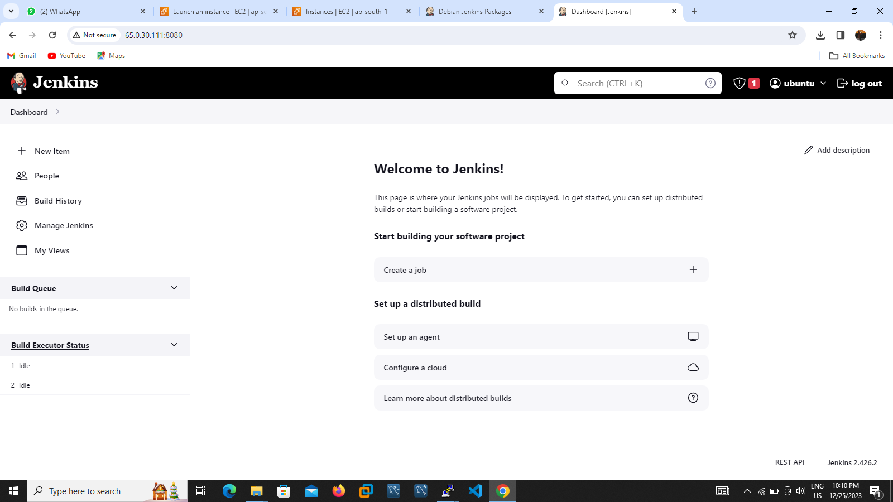

3)Jenkins default page will come then setup username and password her after the page will go to Jenkins page .

4)login to slave server install java only and create one directory in /home/ubuntu/Jenkins

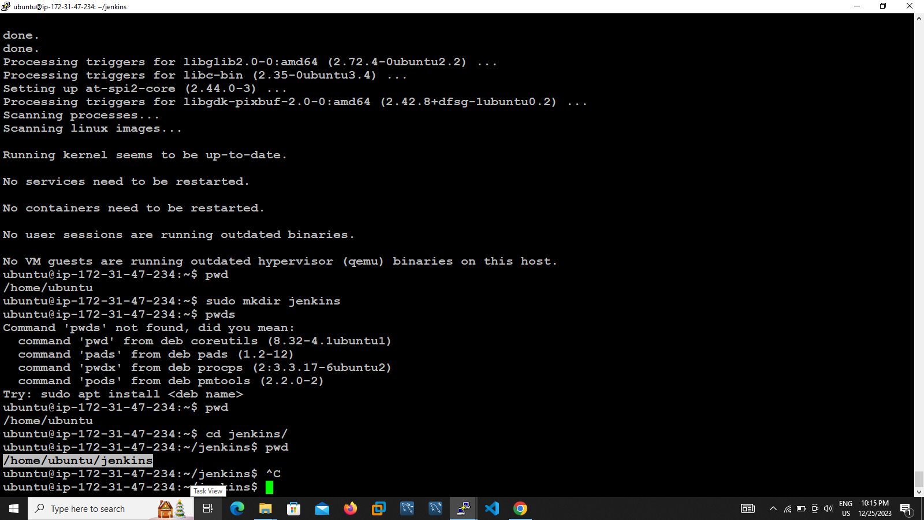

6)go to master server Jenkins page click manage Jenkins -> click node

7)provide name and description and provide no of execution 2 and

Remote root directory path /home/ubuntu/Jenkins

8)provide the slave server ip in host name check box

9)click on add credentials then select open SSH with private key options

10)provide username and ID click on upload key

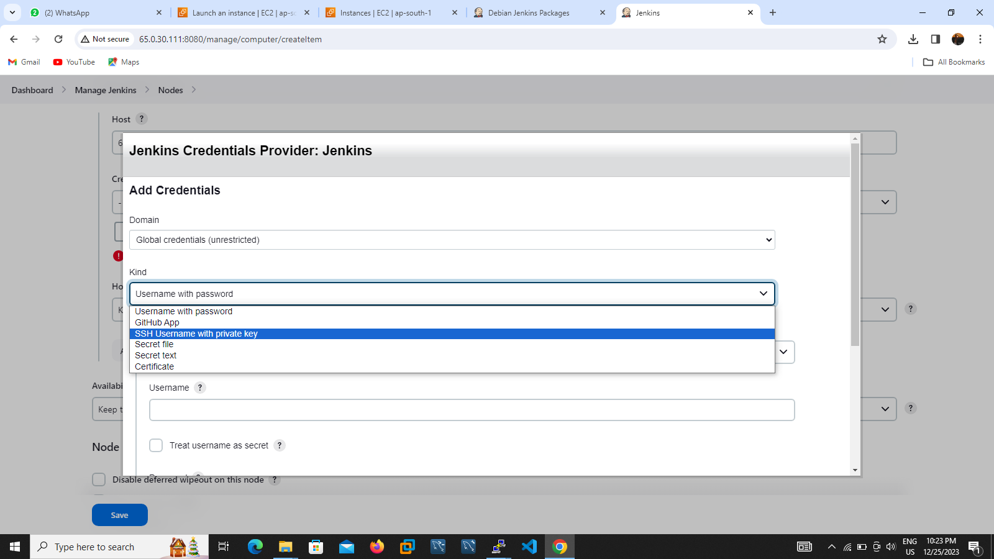

11)Go to your slave server click SSH-keygen command to create private and public key

12) Go to your slave server in /home and check the hidden files

13)three files found rsa_key, rsa_key.pub and authentication key

14)to copy the public ip files paste into the authentication key file

15)to copy the private file paste into the nodes key path then click on add

16)click on save it

17) launch to connect the master server then output will come online

